|  |  |
| --- | --- |
| cetlogo ***CHEMICAL ENGINEERING TRANSACTIONS***  ***VOL. xxx, 2025*** | A publication of  aidiclogo_grande |
| The Italian Association  of Chemical Engineering  Online at www.cetjournal.it |
| Guest Editors: Fabrizio Bezzo, Flavio Manenti, Gabriele Pannocchia, Almerinda di Benedetto  Copyright © 2025, AIDIC Servizi S.r.l. **ISBN** 979-12-81206-17-5; **ISSN** 2283-9216 | |

Techno-economic and environmental assessment of a biorefinery for the valorisation of sesame crop

Juan M. Gonzaleza\*, Angie Y. Salazara, Yeny Portelaa, Eduardo L. Sanchezb, Karina A. Ojedab

a Department of Chemical Engineering, Universidad de la Salle, Bogotá, Colombia 111711

b Department of Chemical Engineering, Universidad de Cartagena, Cartagena, Colombia 130015

\*juanmgonzale@unisalle.edu.co

Sesame (*Sesamum indicum L*) is an oilseed cultivated in tropical regions of Asia, Africa, and South America and is traditionally used in Asian cuisine as cooking oil. Thanks to its adaptability to poor soils and relatively high-temperature conditions, its high oil content (approximately 60%), and its antioxidant properties, sesame is a valuable commodity for the industrial production of food, cosmetics, pharmaceuticals, polymers, and fuels. In this study, a sesame-based biorefinery is proposed to produce food products (refined cooking oil and a vegetable milk substitute), chemical reagents (epoxide sesame oil resin), and fuels (biodiesel and bioethanol) through the esterification of sesame oil and the modification-fermentation of residual sesame crop biomass, respectively. The feasibility of the biorefinery was assessed using life cycle assessment and techno-economic evaluations. Both economic and environmental analysis indicate that all technological pathways are viable for implementation. The results suggest that the production of food-based products offers a faster return on investment and lower environmental impact. However, a combined production strategy incorporating epoxide resin and biodiesel may be considered, depending on market demand.

* 1. Introduction

The biorefinery concept, in which biomass raw materials are converted into biofuels and a wide range of marketable chemical products by emulating an oil refinery, offers promising a pathway to transition our economy from fossil fuel dependence to a more sustainable one. High oil-content vegetables and legumes are good choices as feedstock for biorefineries due to multiple modifications that can be applied to their extracted oils to obtain valuable products via organic chemistry reactions, such as hydroxylation, epoxidation, carboxylation, hydrogenation, and oxidation. Additionally, the utilisation of crop residues to produce ethanol through the hydrolysis of lignocellulosic biomass and fermentation adds significant value. It is also important to emphasise the need to preserve edible biomass for food production. In this context, this study proposes the co-production of food, chemical reagents, and fuels.

Jatropha, palm, coconut, castor, and other vegetable oils have been studied as raw materials for biorefineries. This study presents sesame seeds and their residual biomass as a feasible feedstock for biorefinery production, considering the high oil content of the seeds (approximately 60%), the potential for producing liquid biofuels through the fermentation of residual biomass, and the adaptability of sesame crops to poor soils and relatively high temperatures. This work proposes a biorefinery that integrates the production of edible products (refined cooking oil and a vegetable milk substitute), chemical reagents (an epoxide sesame oil resin), and fuels (biodiesel and bioethanol) through the esterification of sesame oil and the modification-fermentation of residual sesame crop biomass, respectively.

Figure 1 illustrates the proposed processes for valorising the sesame crop. First, sesame seeds are separated from crop residual biomass and dehulled. The biomass is then mechanically pre-treated, hydrolysed to obtain fermentable sugars, and fermented in an aerobic bioreactor with *saccharomyces cerevisiae* to produce ethanol. Kumar et al. proposed an experimental methodology for producing bioethanol from sesame crop residual biomass. Their process involved hydrolysing the biomass into fermentable sugars through microbial and acid pre-treatments, followed by fermentation in an aerobic reactor for 60 h. Experimental results were used to propose a logistic model kinetic mechanism to simulate cumulative bioethanol production (Kumar et al., 2020). Simultaneously, as observed in Figure 1, oil is extracted from sesame seeds and transformed into biodiesel via esterification, into an epoxide oil resin through its epoxidation with acetic acid, and into cooking oil through refining. Additionally, the residual biomass cake was used to produce bioethanol.

Dehonor-Marquez et al. reported the epoxidation of linseed oil with peracetic acid, produced *in situ* by the oxidation of acetic acid with hydrogen peroxide. The epoxidation was catalysed by Amberlite IR-120H exchange resin to avoid the use of a strong acid such as H2SO4, obtaining 97% conversion and 96.3% selectivity towards epoxides (Dehonor-Márquez et al., 2018). Furthermore, biodiesel can be produced by the reaction of triglycerides with an alcohol to produce fatty acid methyl esters, FAME, and glycerol, in a process called transesterification. Several authors have reported the transesterification of sesame oil for biodiesel production (Soltani et al., 2022). Additionally, various extraction and refining steps can be performed to obtain edible sesame oil, with an appropriate selection of processes potentially improving oil composition over time. Shi et al. observed that roasting sesame seeds before extraction resulted in sesame oil with superior oxidative stability and free radical scavenging capacity, beneficial for oil storage and biological activity (Shi et al., 2018). Manahi et al. reported that sesame oil obtained by cold-pressing and subsequent refining steps (neutralisation, decolourisation, and deodorisation) exhibited improved oxidative stability (Manahi et al., 2024). Finally, as shown in Figure 1, a vegetable milk substitute is produced by emulsifying roasted, ground, and sieved sesame seeds in water. Yadav et al. reported an optimised procedure yielding a vegetable milk with desirable consistency (855.6±47.5 g/s), acidity (0.57±0.02% lactic acid equivalent; LAE), flavour and overall acceptability (OAA) (Yadav et al., 2020).

All processes depicted in Figure 1 were simulated using either Aspen Plus®, Aspen Hysys® or SuperPro Designer®, depending on the capabilities of each software and the requirements of the respective processes. The extraction-refining of edible sesame oil and the production of the vegetable milk substitute were simulated in Aspen Plus®. The epoxidation and esterification of sesame oil were simulated in Aspen Hysys®, while bioethanol production was simulated in Super PRO Designer®. In all cases, the UNIQUAC thermodynamic model was employed to represent fluid properties, as the mixtures contained both polar and non-polar components, lacked strong electrolytes, operated under mild pressure conditions (under 10 bar) and had available binary interaction parameters. Additionally, rigorous heat exchanger designs were performed using the Aspen Exchanger Design and Rating (EDR®) tool. The viability of the proposed biorefinery was assessed based on economic and environmental indicators. A life cycle assessment was conducted using SimaPro® software to estimate environmental burdens, while economic feasibility was evaluated through the annualised cost index, CA, and net cash flow, NCF.

*Figure 1. Proposed sesame biorefinery processes*

* 1. Methodology

Environmental and economic evaluation of the proposed biorefinery were implemented in four scenarios for comparison purposes: S1: bioethanol + vegetable milk, S2: bioethanol + edible oil, S3: bioethanol + epoxide resin and S4: bioethanol + biodiesel.

* + 1. Proposed biorefinery

Figure 2 shows proposed unit operations for a sesame oil biorefinery. First, the fermentation of sesame crop residual biomass was simulated in SuperPro Designer® software, following the experimental procedures reported by Kumar et al. In the process, the biomass was washed (WT-101), dried (DR-100) and ground (GR-101) before being fed into R-100 pre-treatment reactor, where fermentable sugars were produced by microbial treatment with *Phanerichaete Chrysosporium*. This was followed by a chemical pre-treatment with H₂SO₄ in reactor R-101. After pH adjustment with NaOH, the resulting mixture of fermentable sugars was fed into FR-100 aerobic reactor and fermented for 60 h with *Saccharomyces Cerevisiae* to produce ethanol. The stream exiting FR-100 was fed into a series of distillation columns (C-100 and C-102) to obtain fuel-grade anhydrous ethanol (Kumar et al., 2020). Furthermore, fatty acid methyl esters, FAME, used as fuel in diesel engines were produced by the reaction of sesame oil, modelled as triolein, with methanol in the presence of NaOH as catalyst. The process was simulated in Aspen Hysys®. Methanol, NaOH and sesame oil were preblended and subsequently heated in shell and tube exchanger H-100 to achieve reaction temperature of 60°C before being fed to reactor R-102. The separation procedures consisted of a decanter (DC-100) to separate the glycerol, a distillation tower (C-102) to recover methanol and a liquid extraction tank (T-103) to wash NaOH from FAME, using water as solvent. Moreover, the epoxidation of sesame oil into an epoxide resin was simulated in Aspen Hysys®, using a conversion reactor (R-103), where hydrogen peroxide an acetic acid react to produce *in-situ* the oxidant agent peracetic acid, which then reacts with sesame oil in the presence of an ionic exchange resin catalyst (Amberlite 120H®) and toluene as solvent (Dehonor-Márquez et al., 2018). The reagents were mixed with recovered acetic acid and toluene then fed to reactor R-103. The catalyst was recovered in filter F-101, while decanter DC-101 was used to separate acetic acid containing aqueous phase and organic phase composed by toluene and the epoxides. The resin was separated from toluene in the stage distillation column C-103. Additionally, the sesame oil extraction process was simulated in Aspen Plus®. This process consisted of drying and roasting the sesame seeds in a convective oven (D-100) operating at 180°C. The cold-pressing of sesame seed into oil and cake was then simulated using a two-step grinding (C-100) and filtering (F-100) procedure. Finally, the simulation of vegetable milk production was performed in in Aspen Plus®, based on the methodology reported by Aydar et al. The process began with the soaking of sesame seeds for 12 hours in water and NaHCO3 (0.5 g NaHCO3/L water) in tank T-100, followed by washing in ambient-temperature water. Next, the seeds were soaked in water at 80°C for 2h (T-101) before being ground for 20 min (G-100). The resulting suspension was filtered (F-100), pasteurised at 80°C for 30 min, and stored at 4°C (Aydar et al., 2020).



Figure 2: *Biorefinery overall diagram. Small equipment not shown for simplicity*

* + 1. Life cycle assessment

Life cycle assessments (LCA) are used to identify the environmental impacts associated with products and services throughout their life cycle. All stages or activities involved in obtaining a product or process are considered, including extraction or procurement of raw materials, processing, and manufacturing, as well as subsequent stages such as transportation, distribution, waste treatment and final disposal. According to the international environmental standard ISO 14040, LCAs must have four steps: goal and scope definition, life cycle inventory analysis, impacts assessment and interpretation.

The goal of a LCA for a sesame biorefinery is to quantify and compare the environmental of the four proposed production scenarios. The selected functional unit was the production of 1 kg of the main products in each scenario. The LCA was implemented in SimaPro 9.3.0.3 software following a cradle-to-gate approach, mass allocation, and system boundary including stages for raw materials extraction, production, and separation. The Ecoinvent v3.6 database was used to account for the environmental impacts of raw materials.

* + 1. Economic evaluation

The economic feasibility of the proposed production routes was assessed by first estimating capital costs (CAPEX) and operational costs (OPEX), followed by the calculation of annualised cost index (CA) and the net cash flow (NCF). CA is the sum of the annual production cost and a reasonable return on the original capital investment (Equation 1). The annual production cost (C) is the sum of the manufacturing costs (COM), and the general expenses (Equation 2). COM comprises direct manufacturing costs (feedstocks, utilities, labour-related operations, and maintenance), operating overhead, and fixed costs (property taxes, insurance, and depreciation). General expenses refer to activities that are conducted by the central operations of a company, which are funded through profits generated from its operating plants. These expenses include selling cots, research, administrative expenses, and management incentive compensation. The total capital investment (CTCI) includes the costs of process equipment (or permanent investment costs, CTPI) and working capital (CWC) (Equation 3). It can be estimated using the method of Guhtrie. CTPI includes the total depreciable capital (CTDC), the cost of land (Cland), the cost of royalties (Croyal), and the cost of plant start-up (Cstartup), all multipliedby an investment site factors (FISF). Finally, Imin represents a reasonable return on investment, which can be taken as 0.2 (Seider et al., 2009).

$C_{A}=C+ i_{min}\left(C_{TCI}\right)$ (1)

$C=COM+general expenses$ (2)

$C_{TCI}=C_{TPI}+C_{WC}$ (3)

$C_{TPI}=F_{ISF}\left(C_{TDC}+C_{land}+C_{royal}+C_{startup}\right)$ (4)

$NCF=AI-C$ (5)

In addition, net cash flow (NCF) was calculated as the difference between the annual income (AI) and the annual production costs, as shown in Equation 5. The annual income was estimated based on the production rate determined by simulation (kg/h) and the market price of each commodity (USD/kg).

* 1. Results and discussion
     1. Life cycle assessment

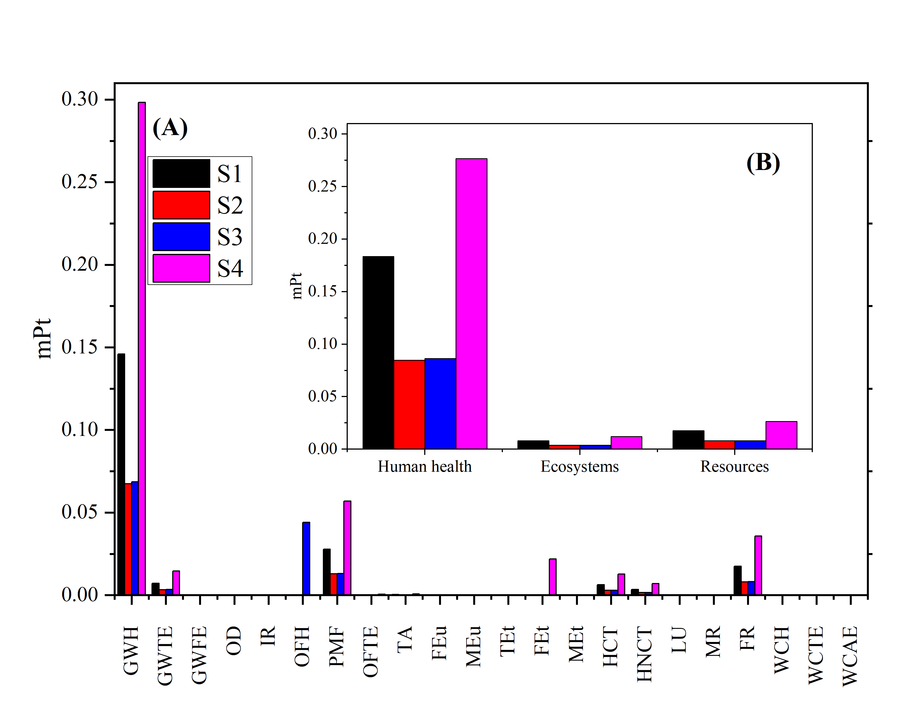

*Figure 3. LCA of scenarios S1-S4, using SimaPro® software, Ecoinvent® and Agri-footprint databases and ReCiPe 2016 Endpoint (H) v1.06 method. Acronyms are explained in the Nomenclature section*

Figure 3 presents the quantification of impact assessment for all biorefinery scenarios using the ReCiPe Endpoint (H) method. The most significant impact categories identified are global warming effects on human health (GWH), particulate matter emissions (PMF), and fossil resource scarcity (FR), with the highest values observed in scenarios involving intensive energy consumption (S1 and S4). These results highlight the environmental trade-offs associated with different valorisation pathways and suggest that prioritising the production of vegetable oil and epoxidised resin could better align with global sustainability goals.However, the high environmental impact observed in energy-intensive scenarios indicates the urgent need for fossil fuel replacement strategies to mitigate these effects across all cases. At the plant’s current location, electricity is primarily generated from natural gas, contributing significantly to greenhouse gas emissions and fossil fuel depletion. A transition towards renewable energy sources such as solar and wind power could substantially reduce the carbon footprint of all biorefinery scenarios. Overall, while the results suggest that vegetable oil and epoxidised resin production are the most environmentally favourable, implementing renewable energy solutions and efficiency improvements in all scenarios could significantly enhance their sustainability.

* + 1. Economic assessment

Table 1 presents the production rate and annual sales for all four studied scenarios, while Table 2 outlines the capital and operational cost of all products. Figure 4 illustrates the results for net cash flow and annualised cost index. The calculations were based on the processing of 1200 kg/h of sesame seeds and 3000 kg/h of sesame crop residual biomass for an operating time of 8000h/year and a plant located in Cartagena, Colombia. The results indicate that all scenarios are profitable in terms of NCF and CA. Scenario S1 generates the highest revenue, primarily due to its high production volume and the strong market prices of vegetable milks driven by the increasing demand for plant-based alternatives to cow milk. The production of food-related products, as in scenarios S1 and S2, requires lower capital investment and operational cost while generating the highest revenue.

Table 1: Production rate and annual sales

|  |  |  |  |  |  |  |
| --- | --- | --- | --- | --- | --- | --- |
| **Scenario** | **Production (metric ton/year)** | | | | | **Sales (USD/year)** |
| Bioethanol | Sesame oil | Vegetable milk | Epoxide resin | Biodiesel |
| S1 | 6444.88 |  | 24,085.04 |  |  | 431,017,320.63 |
| S2 | 6444.88 | 12,042.48 |  |  |  | 95,488,221.14 |
| S3 | 6444.88 |  |  | 3238.00 |  | 28,217,056.23 |
| S4 | 6444.88 |  |  |  | 20,226.56 | 32,877,405.42 |

Table 2: Costs

|  |  |  |
| --- | --- | --- |
| **Product** | **Capital cost (USD)** | **Operational cost (USD/year)** |
| Bioethanol | 37,303,107 | 912,191 |
| Vegetable milk | 1,578 | 2,986 |
| Edible oil | 17,443 | 30,744 |
| Epoxide resin | 2,534,330 | 38,009 |
| Biodiesel | 2,265,630 | 26,841 |

*Figure 4. Comparison of annualised cost index (CA) and net cash flow (NCF), for all scenarios*

Although the production of epoxidised resin and biodiesel, in S3 and S4, involves substantial capital cost and yields lower profits compared with S1 and S2, these products provide diversification opportunities. Epoxide resin are valuable renewable raw materials for plastic production, while biofuels play a crucial role in the transport sector. An overall analysis of the economical results suggests prioritising a core production of bioethanol, vegetable milk and edible oil, while considering a secondary production of biodiesel and epoxide resin based on market demand.

* 1. Conclusions

A sesame biorefinery was proposed for the production of biodiesel, epoxide resin, vegetable milk and sesame oil. The processes were simulated in Aspen plus®, Aspen Hysys® or Superpro Designer®, depending on the capabilities required. The economic feasibility of the technological routes was assessed by calculating the net cash flow and annual cost index, after estimating the total capital investment and the annual operation costs. In addition, environmental impacts were estimated by performing a life cycle analysis in Simapro® software, using Ecoinvent® and Agri-footprint® databases and ReCiPe 2016 Endpoint (H) v1.06 method. Both economic and environmental analysis show that all technological routes are feasible to implement. Considering the results, a core production of food-based products presents the best results in terms of a faster return of investment and less environmental burdens, after implementing strategies to reduce fossil fuels consumption. a secondary production of biodiesel and epoxidised resin can be considered, based on market demand.

Nomenclature

GWH – global warming, human health, Pt

GWTE – global warming, terrestrial ecosystems, Pt

GWFE – global warming, freshwater ecosystems, Pt

OD – stratospheric ozone depletion, Pt

IR – ionizing radiation, Pt

OFH – ozone formation, human health, Pt

OFTE – ozone formation, terrestrial ecosystems, Pt

PMF – fine particulate matter formation, Pt

TA – terrestrial acidification, Pt

FEu – freshwater eutrophication, Pt

Meu – marine water eutrophication, Pt

FEt – fresh water ecotoxicity, Pt

MEt – marine water ecotoxicity, Pt

TEt – terrestrial ecotoxicity, Pt

HCT – human carcinogenic toxicity, Pt

HNCT – human non-carcinogenic toxicity, Pt

LU – land use, Pt

MR – mineral resource scarcity, Pt

FR – fossil resource scarcity, Pt

WCH – water consumption, human heath, Pt

WCTE–water consumption, terrestrial ecosystems, Pt

WCAE – water consumption, aquatic ecosystems, Pt

NCF – net cash flow, USD

AI – annual income, USD

CA – annualised cost index, USD

C – annual production costs, USD

Imin – return on investment

CTCI – total capital investment, USD

CTPI – permanent investment costs, USD

CWC – working capital, USD

FISF – investment site factors

CTDC – total depreciable capital, USD

Cland – cost of land, USD

Croyal – cost of loyalties, USD

Cstartup – cost of plant start-up, USD

**Acknowledgments**

The authors thank funding from Universidad de Cartagena through grant 046-2022.

References

Aydar, E., Tutuncu, S., Azcelik, B., 2020. J Funct Foods 70.

Dehonor-Márquez, E., Nieto-Alarcón, J.F., Vigueras-Santiago, E., Hernández-Lopéz, S., 2018. American Journal of Chemistry 8, 99–106.

Kumar, Pankaj, Kumar, V., Kumar, S., Singh, J., Kumar, Piyush, 2020. Bioresour Technol 297.

Manahi, M.;, Eyvazzadeh, Orang, N., Leila, Kavian, F., 2024. J. Chem. Chem. Eng. (IJCCE) Research Article 43, 2024.

Seider, W., Seader, J., Lewin, D., Widagdo, S., 2009. Product and process design principles. Synthesis, Analysis and Evaluation, 3rd ed. John Wiley & Sons, Inc.

Shi, L., Zheng, L., Zhang, Y., Liu, R., Chang, M., Huang, J., Jin, Q., Zhang, H., Wang, X., 2018. European Journal of Lipid Science and Technology 120.

Soltani, H., Karimi, A., Falahatpisheh, S., 2022. Chemical Product and Process Modeling 17, 55–67.

Yadav, D.K., Veerakyathappa, H.C., Patki, P.E., Sharma, G.K., 2020. Def Life Sci J 5, 38–44.